ParQU

Parking System Using Cloud Computing Based on IoT

High-level Hardware Architecture

Senior Project – Group No. 249

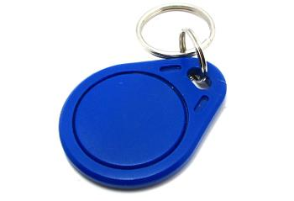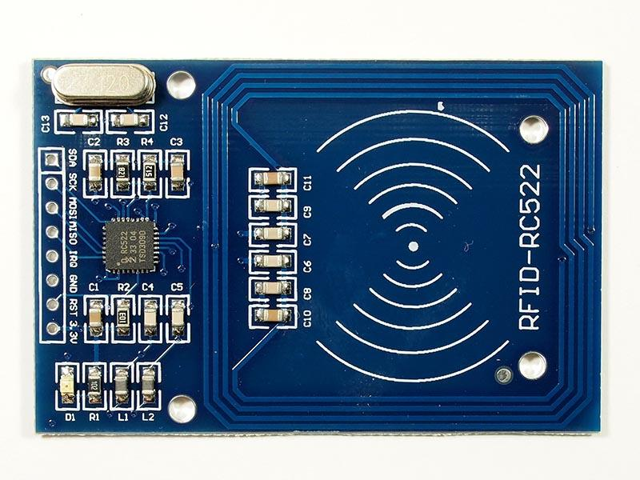

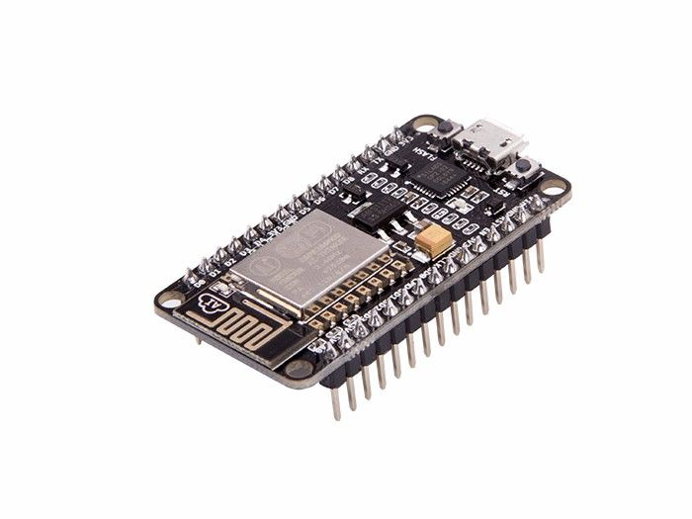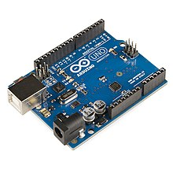

RDIF Reader on the parking lot gate

RFID Tags on cars

*VIP User*

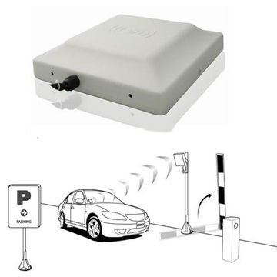

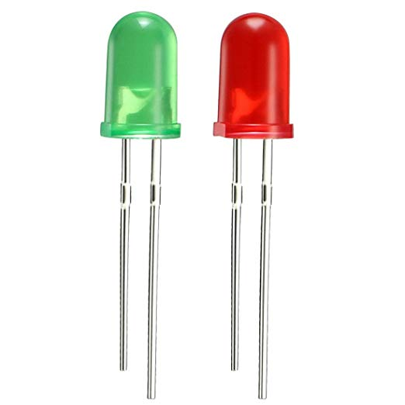

NodeMCU

Arduino

Green LED: On when gate is **opened**

Red LED: On when gate is **closed**



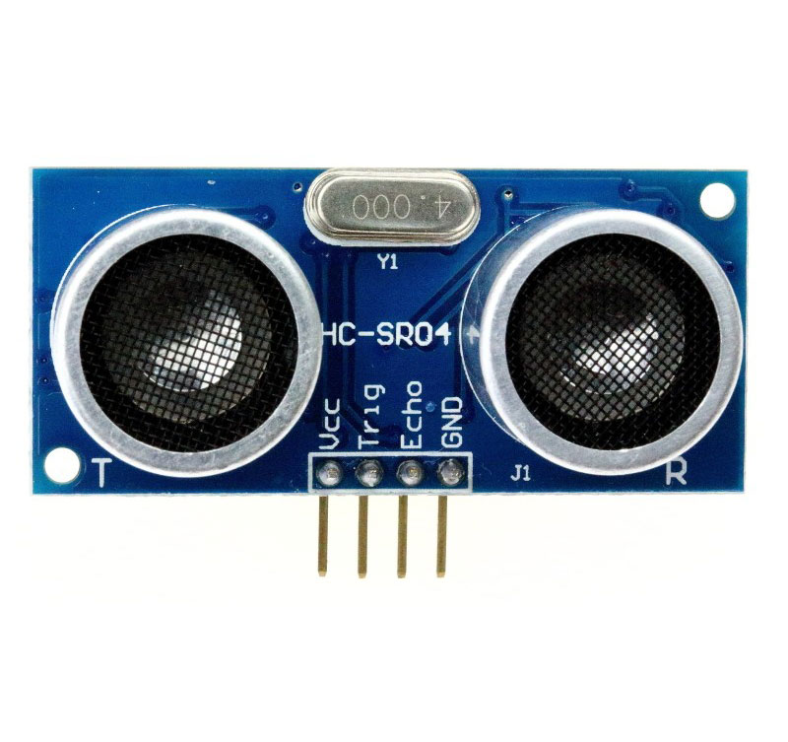

NodeMCU

*User*

Ultrasonic Sensor implemented on each parking spot and connected to Arduino